**35. Chart YAML Part 1**

--- This is the file that has the metadata about our project, and tools like **kube apps**, **Artifact Hub** will use this information and render it on the UI.

**chart.yml**

--- tree

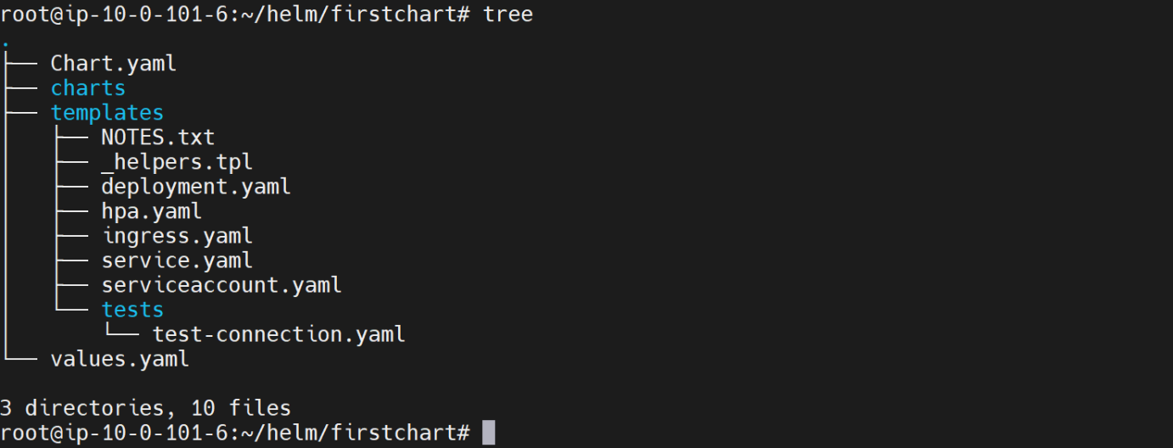

# Cat the chart.yml file

--- cat chart.yml

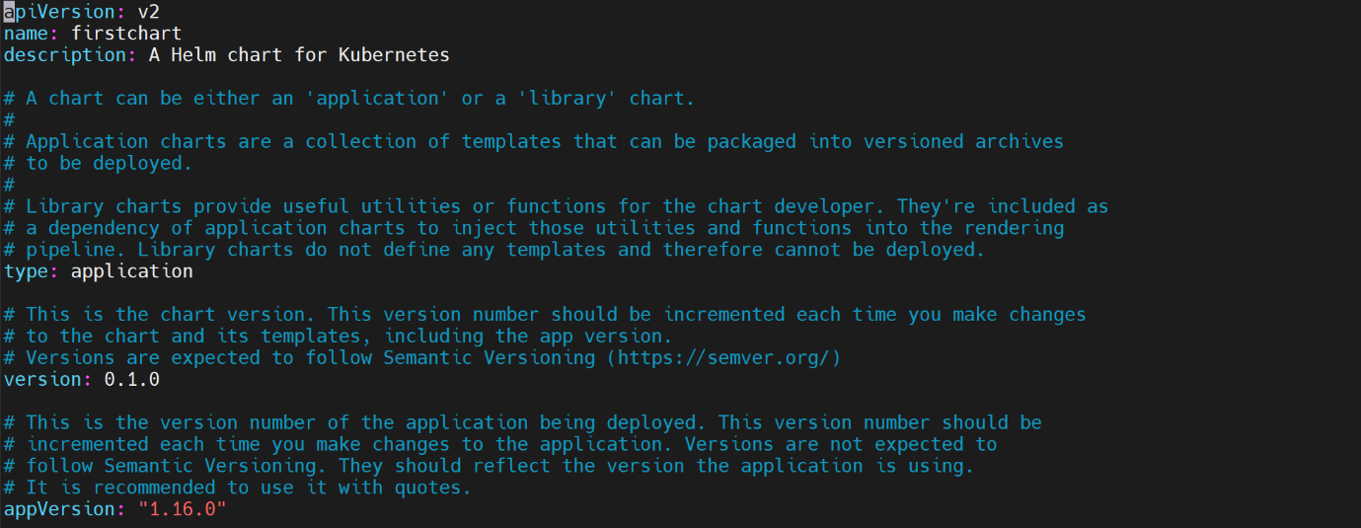

--- **note** - There are three mandatory elements within this chart.yaml. the rest of them are optional.

1. apiVersion
2. name
3. version.

--- **apiVersion** - The apiVersion determines the rest of the document, the structure that needs to be followed by the rest of the document, the elements that can be used, the mandatory elements and the optional elements are determined by the version we use here.

--- Helm 3.0 uses V2 API version, in the future. If this version changes, there might be some new mandatory fields that will be included. Some fields might be deleted and so on.

--- **name** - which is the name of the chart.

--- **description** - the description can be any textual information about what this chart does or what this chart is responsible for.

--- **type** **- application** - type has a lot of explanation here, the type can be application or library. Typically, when we use a chart to deploy or to release or to install application, then this type will be application and it will have the templates folder, which will have the different templates that will be used to install our application on a kubernetes cluster but this can also be library.

--- **type-library** - A library project will have reusable functions that can be used across charts. So, when we define a chart as a library project, it will not have any templates and there will be no releases or installations done using that chart.

--- It simply is to define some reusable functions that can be used across other charts, other library charts or other application charts.

--- **version** - this is the version of the chart; it starts with 0.1.0. You can change this to whatever you want if you want to. They will bump it up. The minor and major versions will be upgraded as you keep changing your chart when you make changes to values.yaml or when you make a change to Chart.yaml etc. You will be upgrading this version just like how you manage versions for your applications.

--- **appVersion:”1.16.0”** - the application that is being packaged through this chart. This is the version of the application that is being packaged using this chart, so you can start with whatever application version you have currently for your application, whether it is 1.0 or 1.9 depending on the version of your application, you will just mention that application version here.

**Additional elements**

--- cat chart.yml.

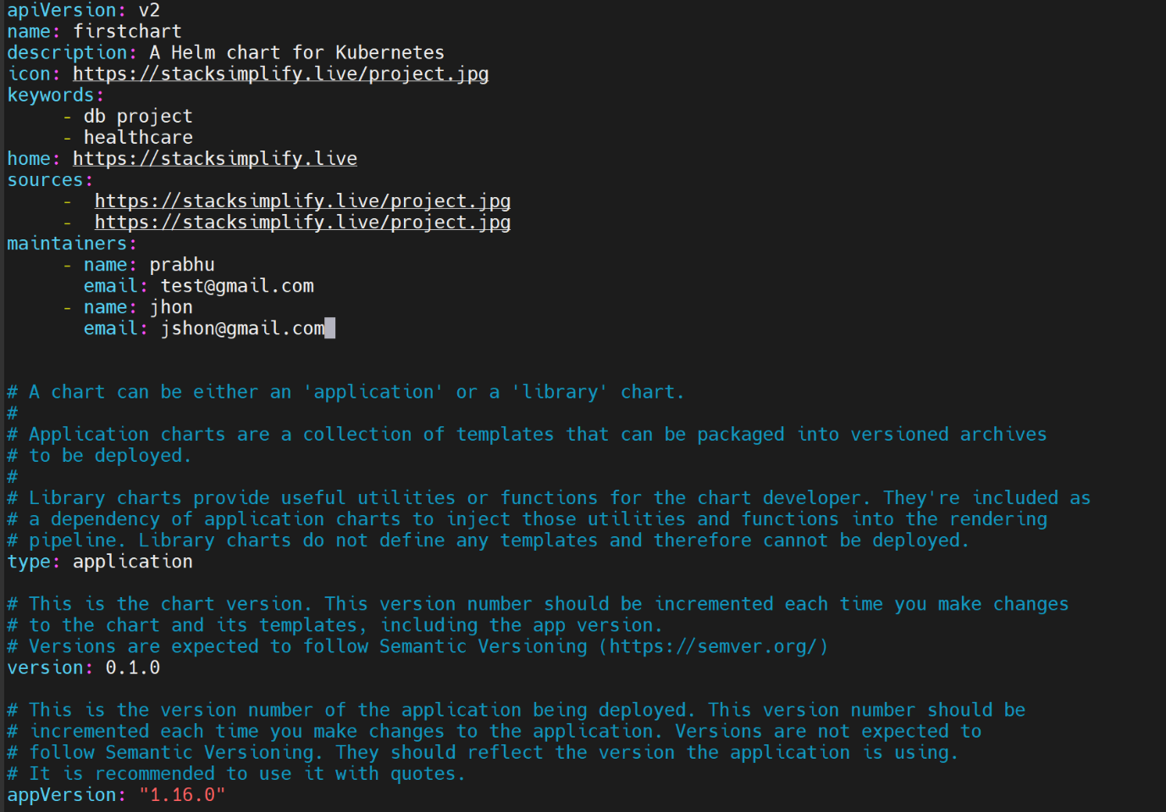

--- you will learn a few more optional elements that you can include in your chart.yaml file.

--- **icon** - we define icon up top here. If you have your project jpg then give the url of it. Tools like Kube apps will take this jpg and render it onto the UI. this jpg should simply represent your project.

--- **keyword** - keywords a list of keywords that explain what this project does. These are like tags. You can think of them like tags.

--- if your application is a DB project, you can use that you can use health care.

--- **home** - This is the url of your project. you can have sources. This is a list of sources. you can have as many numbers of sources as you want. Here. I am using the same website. This can point to the url from which the source for your project can be downloaded.

--- **maintainers** - you can also have maintainers, maintainers who are responsible for maintaining this chart.